Project Report

1.Introduction

1.1 Overview

OWL Material Design App is a mobile application designed to help users create beautiful and functional user interfaces (UI) for their applications. It is a design tool that uses Google's Material Design guidelines as a basis for its interface elements and design principles. The app provides a range of tools and features that allow users to create interactive and engaging UI designs. These include various templates, icons, colours, typography, and animations. Users can also create custom styles and components that they can reuse in their designs.

1.2 Purpose

Owl Material Design is a design system and app development framework that is built on top of Google's Material Design guidelines. Its purpose is to provide developers with a set of tools and guidelines that help them create visually consistent and intuitive mobile and web applications.

2.Problem Definition & Design Thinking

2.1 Empathy Map

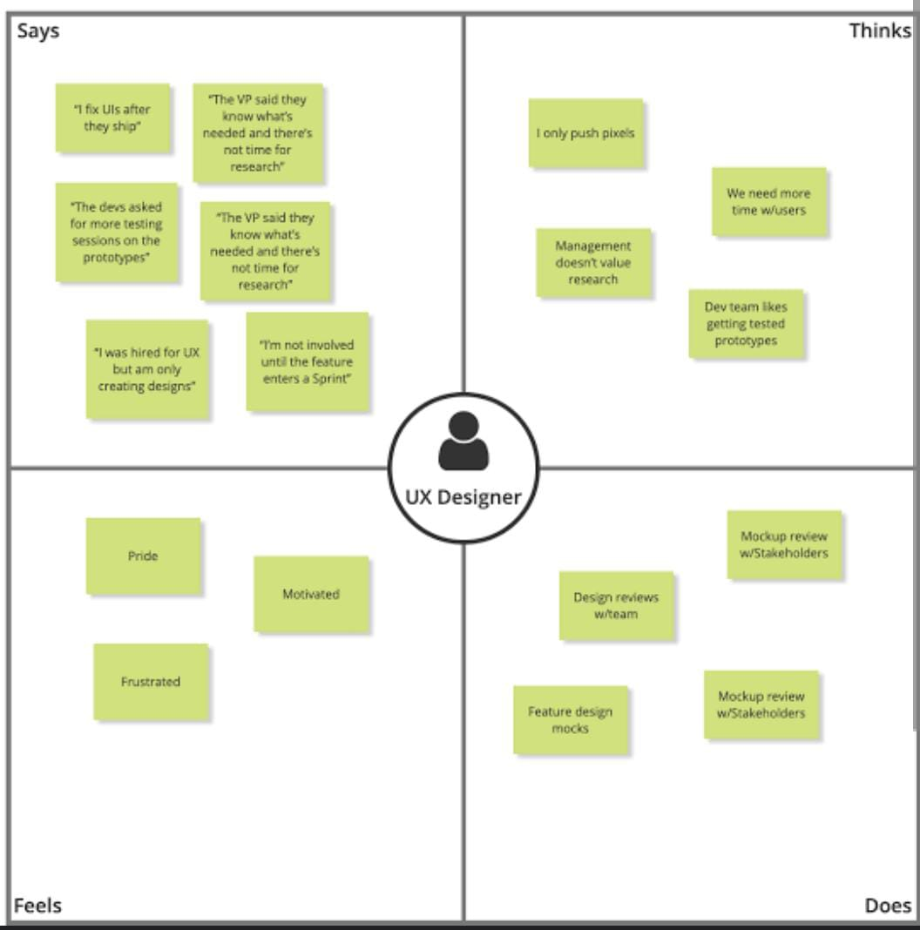

2.2 Ideation &Brain storming Map

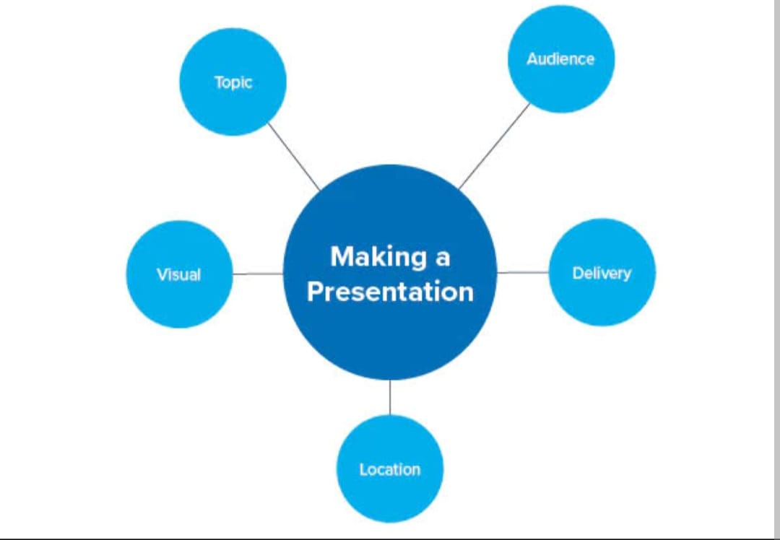

3.Result

3.1Activity & Screenshot

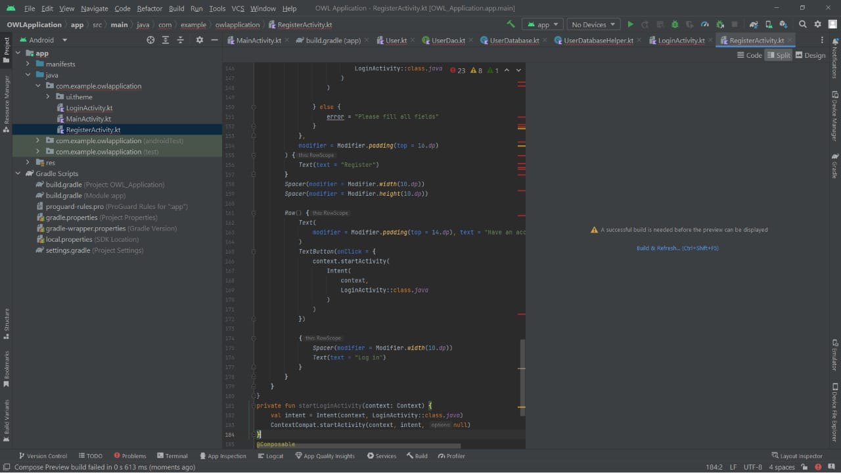

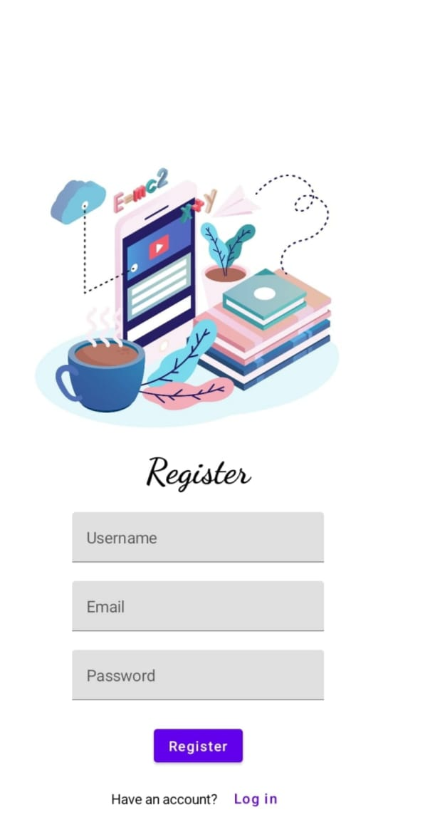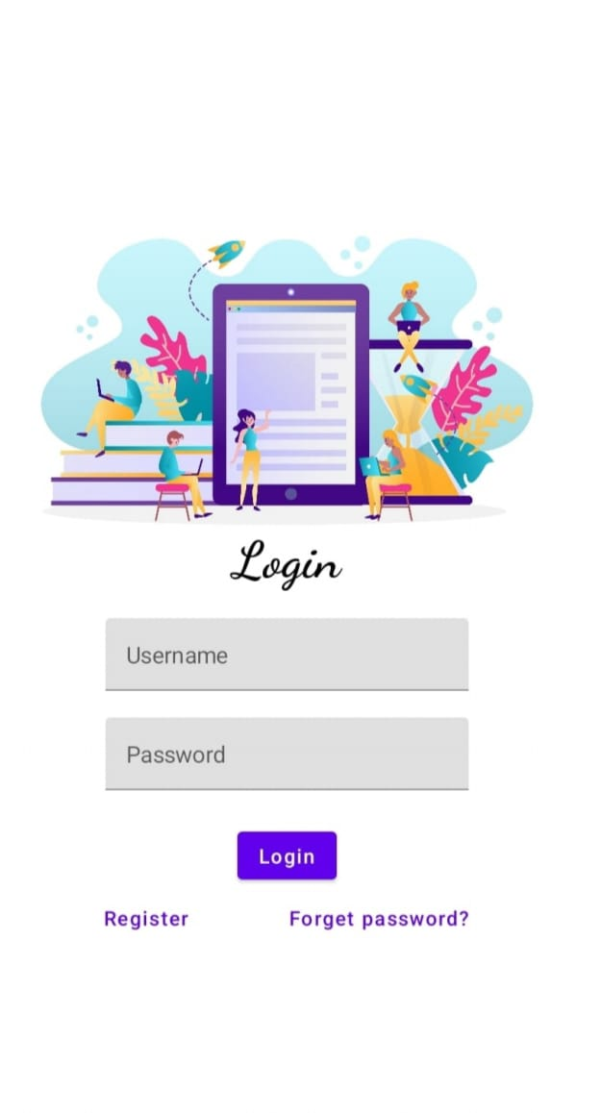

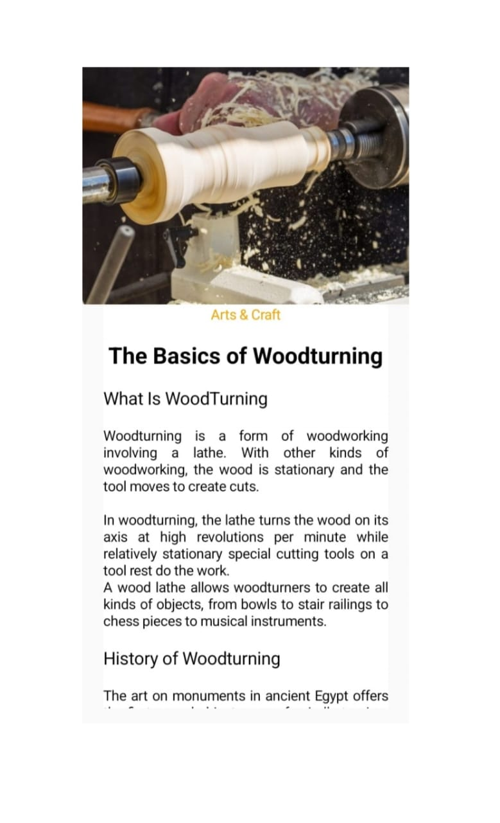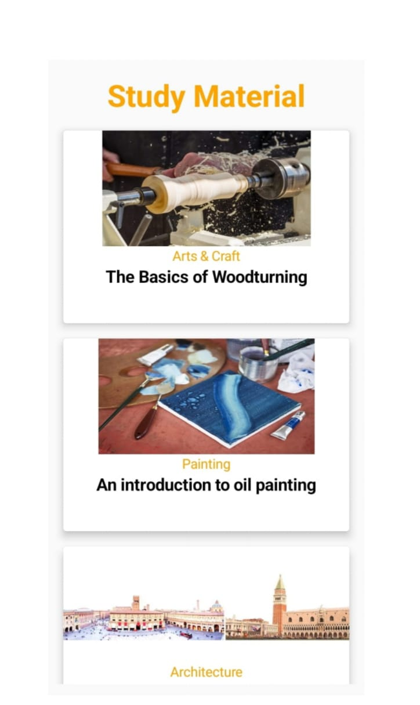

4.TRAILHEAD PROFILE PUBLIC URL

Team lead- HARISHRAJ

<https://developers.google.com/profile/u/Harishraj?authuser=1>

ARJUN-

<https://developers.google.com/profile/u/Arjun23>

NITHINKUMAR-

<https://developers.google.com/profile/u/Nithin2002>

MADHESHWARAN-

<https://developers.google.com/profile/u/praba2311>

5. ADVANTAGES &DISADVANTAGE

Graceful animations. Material designs come with smooth, engaging, and flexible UI transitions and animations, making it easier for users to understand the relationship between different elements on their devices.

6. APPLICATIONS

Owl is an educational app that uses Material Design components and Material Theming to create an energetic, motivational brand experience.

7. CONCLUSION

The conclusion of the owl material design app would involve reviewing the app's functionality, user experience, and visual design to ensure that it meets the objectives and goals set at the outset of the project

8.FUTURE SCOPE

Collaboration is becoming increasingly important in the design process, especially for remote teams. The app could include features that allow multiple designers to work on the same project simultaneously, share feedback, and leave comments.